AES (Advanced Encryption Standard)
AES (Advanced Encryption Standard) is a modern symmetric-key block cipher adopted by the U.S. government in 2001 to replace the outdated DES algorithm. It is now the global standard for encrypting sensitive data in most modern systems (e.g., HTTPS, VPNs, Wi-Fi security).

Feature | Description
Type | Symmetric-key block cipher
Block Size | 128 bits
Key Sizes | 128, 192, or 256 bits
Rounds | 10 rounds for 128-bit keys, 12 for 192-bit, and 14 for 256-bit keys
Structure | Substitution-Permutation Network (SPN), not Feistel
Security | Strong and secure (approved by NIST and used worldwide)
Efficiency | Fast in both hardware and software implementations
Design Origin | Based on the Rijndael cipher designed by Vincent Rijmen and Joan Daemen

DES Structure: Feistel Network
- DES splits the data block into two halves: Left (L) and Right (R)
- Each round:
  - The Right half is processed with a function and key
  - The result is XORed with the Left half
  - Then the halves are swapped
- This is repeated for 16 rounds
Main idea: Only half of the data is processed per round
Decryption is simple: just run the same process in reverse order

AES Structure: Substitution-Permutation Network (SPN)
- AES does not split the block — it works on the entire 128-bit block as a whole
- The 128-bit block is arranged into a 4×4 matrix of bytes (called the "state")
- Each round applies 4 transformations:
Main idea: Every byte is processed in every round
The structure gives stronger mixing and better diffusion

Why SPN (AES) Is Stronger than Feistel (DES)
- SPN (AES) applies multiple layers of substitutions and permutations across all bytes
→ Better at hiding patterns and relationships between input and output
- Feistel (DES) limits processing to one half at a time
→ Easier to analyze and attack with modern techniques

DES processes half the block at a time using Feistel structure → simple but now weak.
AES processes all bytes together using Substitution + Permutation rounds → stronger and more secure.
That’s why AES is said to use an SPN structure, and it offers better confusion and diffusion, which are essential for encryption strength.

Comparison Between AES and DES (Key Characteristics)
- Block Size:
  - DES encrypts data in 64-bit blocks.
  - AES encrypts data in 128-bit blocks.
➤ Larger block size in AES provides better protection against repeating patterns.
- Key Length:
  - DES uses a 56-bit key (plus 8 parity bits).
  - AES supports key sizes of 128, 192, or 256 bits.
➤ AES offers exponentially stronger resistance to brute-force attacks.
- Number of Rounds:
  - DES uses 16 rounds for all keys.
  - AES uses 10, 12, or 14 rounds depending on key length.
➤ More flexible and scalable based on required security level.
- Substitution Mechanism (S-boxes):
  - DES uses 8 small S-boxes, each mapping 6-bit input to 4-bit output.
  - AES uses one large S-box for 8-bit input to 8-bit output.
  - ➤ AES S-box is designed mathematically to resist cryptanalytic attacks better.
- Key Expansion (Key Schedule):
  - DES uses simple bit shifts and permutations to generate round keys.
  - AES uses byte-level transformations, rotations, and mathematical operations (like Rcon and SubWord).
➤ AES key schedule is more complex and less predictable.
- Security Status:
  - DES is outdated and can be broken with modern computing power.
  - AES is still secure and recommended by NIST and other standards bodies.
➤ AES is trusted for securing data in government, military, and industry.

How AES Encryption Works
🔹 What Is the "State"?
- In AES, the plaintext block is 128 bits = 16 bytes.
- These 16 bytes are arranged into a 4×4 matrix, called the state.
- This matrix is processed throughout the encryption rounds.

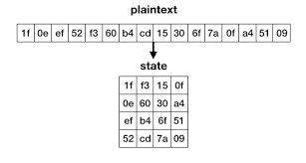

AES fills the state matrix in column-major order
AES encryption consists of multiple rounds:
- 10 rounds for AES-128
- 12 rounds for AES-192
- 14 rounds for AES-256
Each round applies 4 operations to the state:
- SubBytes
- ShiftRows
- MixColumns
- AddRoundKey
Note: The first round starts with AddRoundKey only.
The final round skips MixColumns.

1. SubBytes (Substitution Step)
SubBytes replaces each byte in the AES state matrix with another byte using a predefined lookup table called the AES S-box.
The S-box (substitution box) is a 16×16 table that maps every possible byte (0x00 to 0xFF) to a unique substituted value.
This substitution is non-linear — meaning the output cannot be predicted with a simple equation — which makes the cipher resistant to linear and differential cryptanalysis.
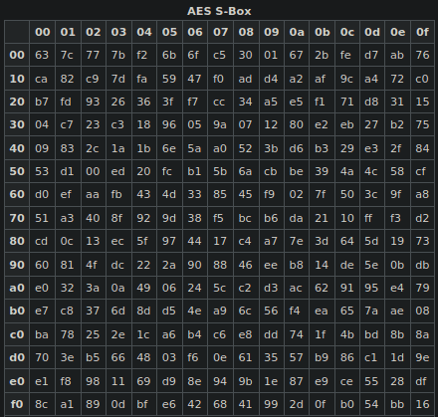

Use the S-box to substitute each byte
To look up a byte in the S-box:
- The first hex digit is the row.
- The second hex digit is the column.
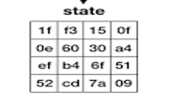
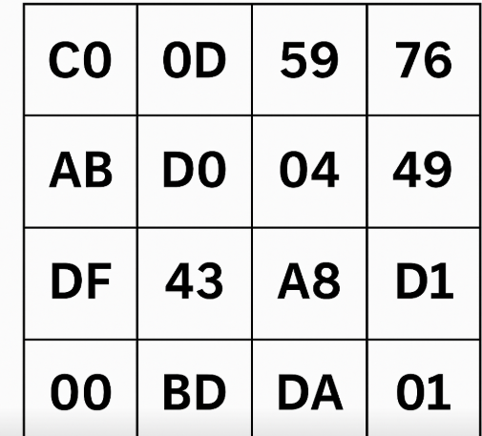

2. ShiftRows (Permutation Step)
Each row of the state is shifted to the left by a certain number of positions:
- Row 0 → no shift
- Row 1 → shift by 1
- Row 2 → shift by 2
- Row 3 → shift by 3
ShiftRows helps achieve diffusion.
Note: Shifting is circular — the bytes that are shifted out from the left re-enter from the right.
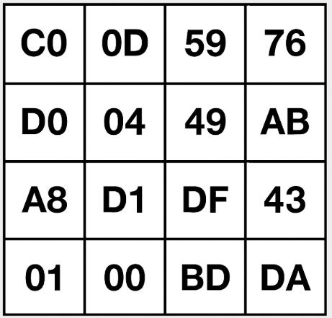

Step 3 – MixColumns (Mixing Step in AES)
In this step:
- AES treats each column of the state matrix as a 4-byte vector.
- This column is multiplied by a fixed 4×4 matrix, using arithmetic over Galois Field GF(2⁸) a special kind of finite field used in cryptography.
The result:
➡ Every output byte depends on all 4 input bytes in the same column, increasing diffusion.
This multiplication is done in GF(2⁸) (not normal integer math).

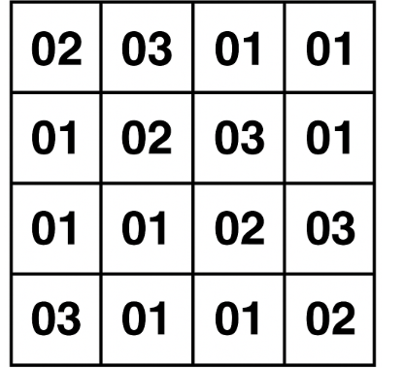

Step 4 – AddRoundKey (Key Mixing Step)
In this step, AES XORs the current state with a round key that was generated from the original encryption key using the AES Key Schedule.
This is not optional — encryption without it would be completely insecure.
How It Works
- AES has multiple rounds (e.g 10 for AES-128).
- In each round, AES uses a different 128-bit round key.
- The AddRoundKey step XORs each byte in the state with the corresponding byte from the round key:
NewState[i][j] = State[i][j] ⊕ RoundKey[i][j]
Why Is AddRoundKey Critical?
- It's the only step that uses the actual encryption key.
- Without this step, everything else (S-box, MixColumns, ShiftRows) could be reversed.
- The security of AES completely depends on the secrecy and correctness of this operation.

Step | Round 0 | Round 1-9 (1-13) | Final Round
Add round key | ✓ | ✓ | ✓
SubBytes | X | ✓ | ✓
ShiftRows | X | ✓ | ✓
MixCoulmns | X | ✓ | X

Input:
- 128-bit plaintext (16 bytes of data)
- 128-bit secret key (16 bytes of key)
1. Key Expansion
- AES takes the 128-bit key and generates 11 round keys (one for each round).
- Each round key is 128 bits.
- Total = 11 round keys × 16 bytes = 176 bytes
- These keys are used in the AddRoundKey step later.
2. Initial Round (Round 0)
Operation:
- AddRoundKey → XOR the plaintext with the first round key (RoundKey 0)
This mixes the data with the secret key before any other transformation.

3. Main Rounds (Rounds 1 to 9)
Each round does 4 steps:
- SubBytes
→ Substitute each byte using the AES S-box (confusion)
- ShiftRows
→ Shift the rows of the 4x4 state matrix to the left (diffusion)
- MixColumns
→ Mix bytes in each column using math over GF(2⁸) (more diffusion)
- AddRoundKey
→ XOR the result with the round key (from key schedule)
Repeat this full process 9 times with different round keys.

Final Round (Round 10)
Same as above BUT skip the MixColumns step

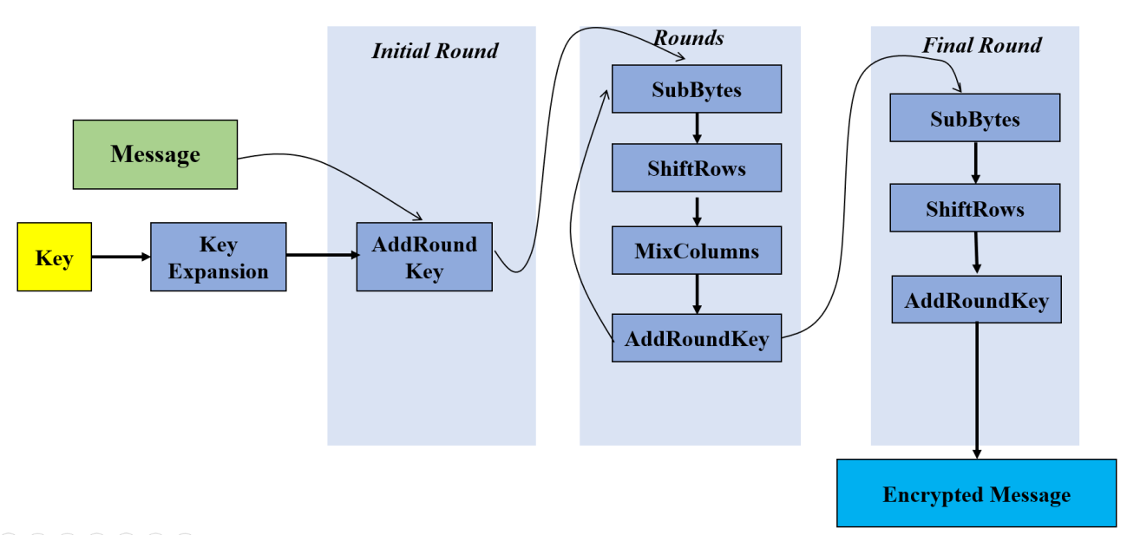

Why Was AES Introduced to Replace DES?
1. DES Became Insecure
- Key Size Too Short: DES uses a 56-bit key → only 2⁵⁶ possibilities.
- In the 1970s this was secure. But by the 1990s, modern computers could brute-force a DES key in less than a day.
- In 1998, the Electronic Frontier Foundation (EFF) built a machine that broke DES in 56 hours.
2. Need for a Modern, Flexible Standard
- DES was designed for hardware, not efficient in software.
- DES only supports a 64-bit block size, which is too small for modern systems.
- The U.S. government and NIST started looking for a replacement in the 1990s.
Before AES, many systems used 3DES to improve DES security, but it is slower than AES
Still vulnerable to known-plaintext attacks and meet-in-the-middle attacks

3. AES Was Created to Meet These Needs
- AES key sizes: 128, 192, or 256 bits → exponentially stronger than DES.
- Block size: 128 bits → more secure against pattern attacks.
- Efficient in both hardware and software
- Selected by NIST in 2001 after a public competition (winner: Rijndael)

Why Is AES Still Considered Secure?
- No practical attacks have been found against the full AES algorithm (AES-128, AES-192, or AES-256).
- It’s been in use for over 20 years, and remains the world standard for encryption in:
  - Web (TLS/HTTPS)
  - Banking
  - Wi-Fi (WPA2/WPA3)
  - Disk encryption (BitLocker, VeraCrypt)
- It’s open, peer-reviewed, and standardized by NIST.
- Designed with:
  - N on-linear S-box to prevent pattern prediction.
  - Substitution-Permutation Network (SPN) that ensures confusion and diffusion
  - complex key schedule that avoids weak keys
- key sizes are extremely large:
  - AES-128 → 2¹²⁸ possible keys
  - AES-256 → 2²⁵⁶ possible keys (more than atoms in the universe)

Where Is AES Used?
- SSL/TLS (secure websites)
- Secure messaging apps (Signal, WhatsApp)
- VPN tunnels (IPsec) [AES-256-CBC , AES-256-GCM]
- Wi-Fi encryption (WPA2, WPA3)
- Encrypted file systems

Known Attacks on AES (Theoretical Only)
None of these attacks break full AES — they only work on reduced-round versions (e.g., 6 or 7 rounds out of 10).
1. Differential Cryptanalysis
- Tries to analyze how small changes in input affect output
- AES’s S-box and structure resist this very well
2. Linear Cryptanalysis
- Tries to approximate AES with linear equations
- Not effective beyond a few rounds .
3. Related-Key Attacks
- Theoretical attacks where the attacker can force certain key relations
- AES key schedule is strong, especially in AES-128 and AES-256
4. Side-Channel Attacks
- Attacks that exploit hardware behavior (timing, power consumption)
- These are not flaws in AES, but in implementation
- Can be prevented with secure coding and constant-time algorithms
5. Brute-Force Attack
- Try every possible key until you find the right one.
- Key sizes:
  - AES-128 → 2¹²⁸ keys (infeasible)
  - AES-256 → 2²⁵⁶ keys (astronomical)

Is AES-256 more secure than AES-128?
Yes, but:
- AES-128 is already strong enough for most real-world uses
- AES-256 is used in military-grade and long-term protection
- AES-128 is faster in many systems

AES is still secure today because it’s based on strong math, with no known weaknesses in the full algorithm. It’s flexible, fast, and trusted by governments, banks, and browsers worldwide. Even AES-128 is unbreakable with current technology.

AES Modes of Operation
AES is a block cipher — it processes data in fixed-size 128-bit blocks.
But real-world data (like a file, image, or message) is usually longer than 128 bits.
So we need "modes of operation" to tell AES how to handle multiple blocks securely.
ECB – Electronic Code Book
🔸 How It Works:
- Each plaintext block is encrypted independently.
- Same input block → same output block.
🔸 Problems:
- Not semantically secure
- If there are repeating blocks in the plaintext, you will see repeating blocks in the ciphertext
- Patterns leak, especially in images or structured data

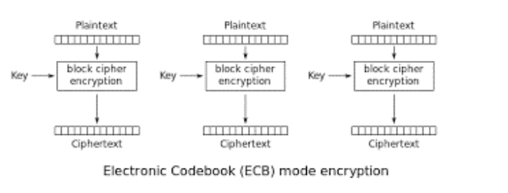
CBC – Cipher Block Chaining
🔸 How It Works:
- Each plaintext block is XORed with the previous ciphertext block before encryption.
- The first block is XORed with a random IV (Initialization Vector)
🔸 Benefits:
- Same plaintext will produce different ciphertext each time (if IV changes)
- Patterns are completely hidden
🔸 Requires:
- An IV (not secret, but must be random and unique per message)
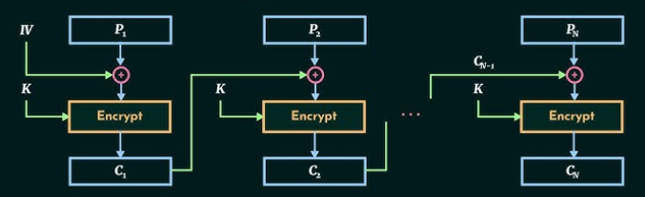

CTR – Counter Mode
How It Works:
- Turns AES into a stream cipher
- Uses a counter + nonce (like IV) for each block
- AES encrypts the counter and XORs it with the plaintext
Benefits:
- Very fast, can be parallelized
- Used in many modern applications
- Can encrypt and decrypt in parallel

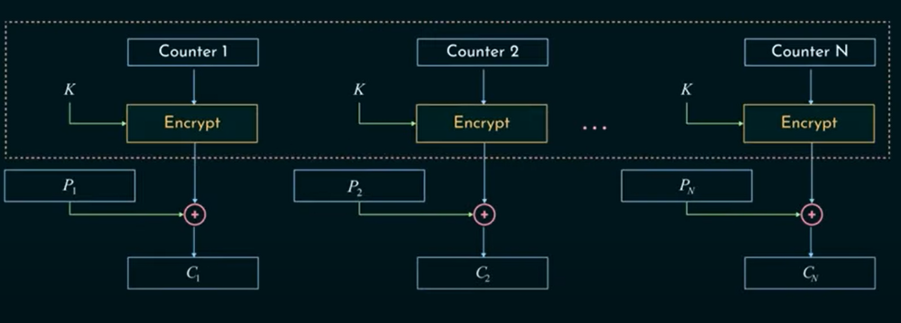

GCM – Galois/Counter Mode
How It Works:
- Based on CTR mode
- Adds authentication → ensures integrity and authenticity of the message
- Used in HTTPS (TLS 1.2/1.3)
Benefits:
- Fast, secure, and authenticated
- Widely used in modern systems (VPNs, TLS, secure messaging)

